Hello Parent/Guardian,

529 Edmund St, Aberdeen MD, 21001
P: (410) 272-3278 F: (410) 272-5457
Email: ico@innercountyoutreach.org

www.innercountyoutreach.org

Board of Directors

Nathaniel Johnson,
President

Bobbye Matthews,
Chairman

Peter Dacey Dominique Gillis Raymond Fischer Norma Johnson Jessie Shanks
Jospeh Cassilly
Shnay White-Turner
Natalie Johnson

Advisory Board

Louis Gordon
Jamilah Oatis-Davidge
Jowanda Strickland-Lucas
Dr. Eva Thornton
On behalf of Inner County Outreach, Inc. (ICO) I would like to thank you for entrusting us with the care of your child while they attend the Inner County Outreach’s After School Program (ICO ASP). Here at ICO we strive to provide you and your child with the best service for their educational growth and desire to be involved in every aspect. We know how important your child’s progress is to you and the ICO family wishes to aid in ensuring that they succeed.

In order to better track your child’s educational progress, we have implemented a new policy for the ASP that grants permission to a designated ICO staff member to access your child’s log-in information to Home Access Center (HAC) along with the appropriate school records. It is important to note, this is now a requirement for ASP. Without a signed Release of Information consent form your child will not be able to participate in any activities associated with the ASP.

Our main priority is the growth and success of your child and we hope that with your partnership we achieve just that for your child.

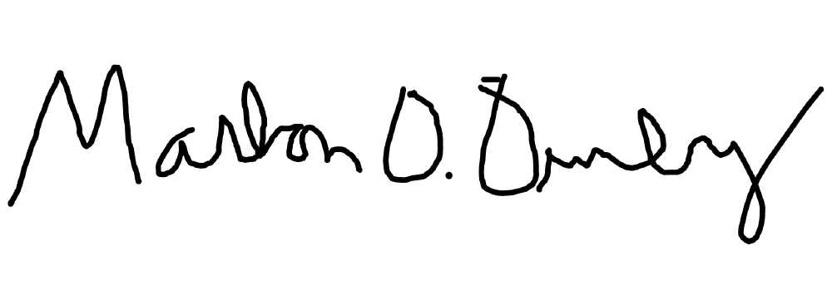
Thank you,

Marlon Demby
After School Program Lead

Student Application for the 2023-2024 Academic Year
* There is no fee associated with this program, all services are free to members of the community*

Childs Name: Date of Birth:

Parent/Guardian (s) Name:

Street Address: City: State: Zip:

Home Phone: Work Phone: Cell Phone:

Email:

What school is your child attending for the 2023-2024 Academic Year: Grade:

How did you learn about the program: (check all that apply)

□Flyer □Word of Mouth □Internet □Other:

What learning strategies work best with your child? (Check all that apply)

□Repetition □ Step-By-Step □ Visual Aid□ Encouragement □Other:

If your child has any special needs or leaning issues, please list them below:

Does your child have an IEP (Individualized Educational Plan) □ Yes □No (if yes, please provide ICO with a copy)
Would you like to receive monthly updates of your child’s progress? □Yes □No If yes, what form of contact is best for you? □Phone □Email □Personal Contact Please describe some of your child’s hobbies:

In order for us to best serve your student, we need you to provide us with your HAC login information so that we can keep in contact with teachers and monitor assignments. In order for your student to participate in the After School Program this information must be provided.

Username:

Password:

By signing below, you are confirming that all the information contained in this application is correct and complete, you understand that space and availability is limited, you understand and you have read and agree to abide by ICO After School Program Policies and Rules as described in this application.

Date:
Child’s Signature
Date:
Parent/Guardians Signature

Emergency Contact Information

Emergency Contact Information for each child will be contained in an emergency contact file/folder located at Inner County Outreach. In addition, emergency contact information will be held in the first section of each student’s file.
Emergency Contact Information:

- Name of emergency contact: Phone: Address Relationship to child:

- Name of Physician: Phone: Address

- Health Care Insurance Carrier: Health Care ID number: MA # (if applicable):

- Name of guardian or person to provide emergency medical consent:

Address: Phone:

Permission to Photograph

Date:

Childs Name:

I hereby give permission for my child to have his/her picture taken while participating in ICO ASP. The picture will be used for identification purposes only and will be kept in each childs individual binder.

Witness: Date:

Child: Date:

Parent/Guardian: Date:

After School Program Confidentiality Statement
Inner County Outreach is committed to the principles of data protection with a view to ensuring the individuals rights to confidentiality. Information contained in family/individual records, during the admission process, or through personal disclosure will be maintained in a confidential manner at all times.
Therefore we will:
- Obtain and process information fairly
- Keep information only for specified, explicit, and lawful purposes
- Use and disclose information only in ways compatible with these purposes
- Keep information safe and secure
- Keep information accurate, complete, and up-to-date
- Ensure that information is adequate, relevant, and not excessive
- Retain information for no longer than is necessary for the purpose or purposes stated
- Give a copy of his/her personal data to an individual with prior consent However, in relation to child protection and welfare we undertake that:
- Information will only be forwarded on a ‘need to know’ basis in order to safeguard the child/young person.
- Giving such information to others for the protection of the child/young person is not a breach of confidentiality.
- We cannot guarantee total confidentiality where the interest of the child/young person is at risk.
- Images of a child will not be used for any reason without the consent of the primary caregiver. We cannot, however, guarantee that cameras/videos will not be used at public events.
- Procedures are in place for recording and storing information in line with our confidentiality statement.

Signature of Guardian: Date: ICO Witness: Date:

Policies and Procedures
PROGRAM: Inner County Outreach’s After School Program will be held at 529 Edmund Street Aberdeen, MD 21001 in the Educational Building. The program will operate Monday through Thursday from 2:00 pm-6:00 pm. During each session, snacks, drinks, and recreational time will be provided to your child by our staff.

ELIGIBILITY: To sign up for free tutoring, you must be a current student of a Harford County School. You must also fully complete and sign the Student Application before being admitted into the After School program.

LOCATION / SIGNING IN & OUT: All tutoring will occur at Inner County Outreach, 529 Edmund Street Aberdeen MD, in the Educational Building. Your child is required to sign in and sign out on the attendance chart every time he/she attends a session.
ATTENDANCE POLICY: Attendance is a very important factor in helping your child benefit from our program. If your child misses multiple tutorial sessions, we will request his/her removal from the program. Please be mindful that the tutors are not teachers and are there to provide aid, not to do the work for your child. It is the responsibility of your child to attend class and come prepared for tutorial (this includes but is not limited to bringing their books, notes, syllabus, etc. with them during each session). In addition, our tutors are not experts on every subject but will help your child discover the answer by using multiple resources. Example of resources: student’s books, notes, and various internet sites.
DISCIPLINE POLICY: The staff holds the children to high standards and will model the appropriate behavior that is expected to be followed. The staff of the After School Program will seek to do their best at praising, rewarding, and encouraging your child(ren) while at the same time, providing options for inappropriate behavior. The behavioral plan for any disciplinary actions that need to be taken are as follows:

- 1st offense: Time out from current activity, written notice given to parent.
- 2nd offense: Time out with program administrator, written notice given to parent.
- 3rd offense: One (1) day suspension from the ASP and a scheduled meeting to include the child, parents, and After School Program Director.
- 4th offense: Three (3) day suspension from the ASP and a final scheduled meeting.
- 5th offense: The student will be expelled from the ASP for the remainder of the school year.
**Exceptions to the discipline plan: Biting, fighting with another student, or being disrespectful to any tutor will result in the child being immediately sent to the Program Director where appropriate consequences will be given.

Acknowledgement of Receipt of Policies and Procedures Manual

I have received a copy of Inner County Outreach After School Program Policies and Procedures manual on the date listed below. I understand that I am expected to read the entire manual. Additionally, I will sign the two copies of this Acknowledgment of Receipt, retain one copy for myself, and return one copy to Marlon Demby. I understand that this form will be retained in the child’s file.

Signature of Child (if over 10 years old) Date

Parent/Guardian Signature Date

ICO Staff Signature Date

Release of Information Consent Form

This is a consent for the release of information for_______________
(Name of Student)

(Date of Birth)

I authorize Inner County Outreach, Inc (ICO) to release or obtain the following specific information: Home Access Care and account username and password information.
This information may be used only for the purpose of tracking and reporting grades and academic progress of students receiving support from ICO's After School Program.
I understand that I have the right to see this information at any time. I understand that I can revoke this consent in writing to both the person giving and the person receiving the information. Any information already obtained may be used as stated on the consent. I understand the requested or provided information is needed to determine the progress of students within the ICO's After School Program. This consent is valid only until the termination of services for students in the program. This consent is automatically renewed unless revoked in writing sooner.

By signing below, I affirm that l am the parent/guardian of the student named on the consent form and I have read this release or it has been read to me, and I understand its content.

Parent/Guardian of Student Date

Consent Witnessed By Date

This information has been disclosed to you from records whose confidentiality is protected by federal law. Federal regulations prohibit further disclosure without specific written consent from the person to who it pertains.

